CCHS Mathematics II
More Functions, More Features
Module 4 - Assessment Study Guide

Define the following Mathematical Terms

Piecewise Function | Piecewise Graph | Interval Notation | Speed
Distance | Range | Domain | Rate of Change
Minimum | maximum | Vertex form | Factored Forms
x-intercept | y-intercept | Axis of symmetry | Standard Form
Parabola | Perfect square trinomials | Imaginary#’s i | Whole numbers
Inverse function | Quadratic | Complex numbers | Rational

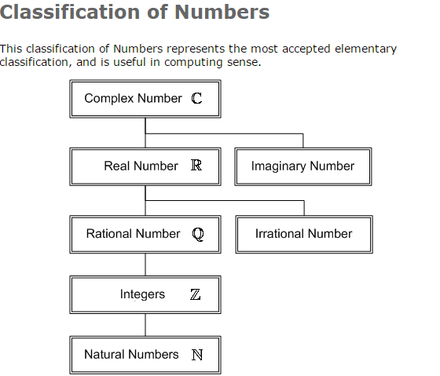

http://myhandbook.info/pics/math/class-numbers.gif
Understand the following Tasks
- Match the function equation with it’s inverse.
- Evaluate and solve functions solutions.
- Identify the fastest
- Identify the domain of a piecewise function.
- Identify the range of a piecewise function.
- Operational with radical expressions.
- Graph absolute value functions
- Graph inverse of a function in factored form
- Graph the inverse of a function in vertex form.
- Graph the inverse of a function in standard form.

