CCHS Mathematics II
Quadratic Equations
Module 3 - Assessment Study Guide

Define the following Mathematical Terms

Zero exponent | Negative exponent | Radical form | Exponential function
Exponential Expressions | Zero exponent | Roots | Solutions
minimum | maximum | Vertex form | Factored Forms
x-intercept | y-intercept | Axis of symmetry | Standard Form
Parabola | Perfect square trinomials | Imaginary#’s i | Whole numbers
integers | Quadratic | complex | rational

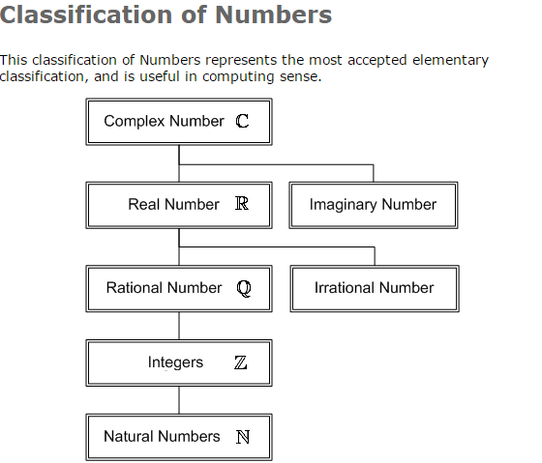

http://myhandbook.info/pics/math/class-numbers.gif
Understand the following Tasks
- Identify the fastest method for factoring a quadratic equation.
- Prove A^{Zero} = 1.
- Prove A⁻¹= 1/A.
- Solve imaginary numbers raised to different formulas.
- Identify whether a number is a whole numbers, integers, rational, and complex numbers.
- Complete the square of a quadratic
- Factor a quadratic.
- Use Quadratic Equation.

